Northern Lights Arts Council Scholarship
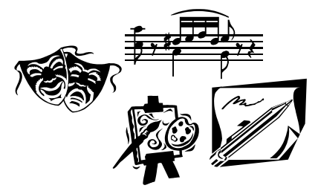
Application deadline: May 6, 2019
Qualifications:
- Applicants must have a home residence in Cavalier County
- Applicants must be at least a college sophomore with a declared major or minor in the arts. (Arts being defined as music, art, drama, creative writing, design or a related field.)
- Applicants must include one recommendation from someone acquainted with your studies in the arts.
Name: _______________________________Phone #: _________________
Address, City, State, Zip: ___________________________________________
Email Address: ____________________________Date of Birth:____________
Name of parent(s) or legal guardian(s): _________________________________
Name of college currently attending: ___________________________________
Major of Study:______________________Minor:_______________________
Signature: _________________________________ Date: _______________
Please return completed application to:
Northern Lights Arts Council
Attn: Scholarship
PO Box 162
Langdon, ND 58249
Please have the recommendation sent to the same address.
Please answer the following questions as thoroughly as possible (use additional sheets if necessary):
- What school will you be attending, if different from the one in which you are currently enrolled?

- Have you had an opportunity to be employed? If so, what type of job or jobs have you held? Please list these jobs along with names of employers.

- List your interests, activities, organizations and offices held which have contributed to your development.

- (Optional) How did you hear about this scholarship?

